**Assignment 4 Report**

**Aditya Kharbanda, 23364313**

**Task1**

* BFS was implemented iteratively using a Queue.
* DFS was implemented recursively.
* A struct of a linked list Node and a separate struct of all head nodes was created
* The Graph Struct included defining the number of nodes and an array of head nodes, that represented the heads of all the adjacency lists.

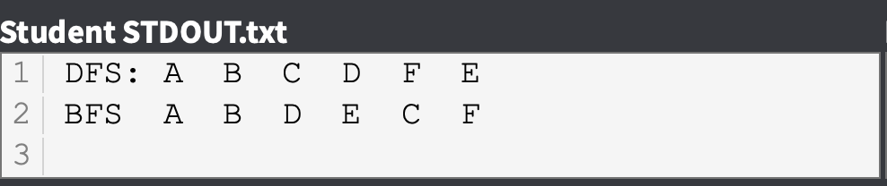

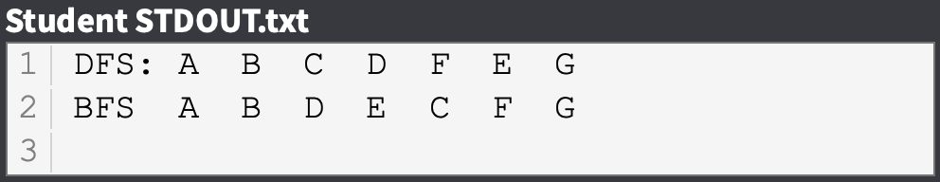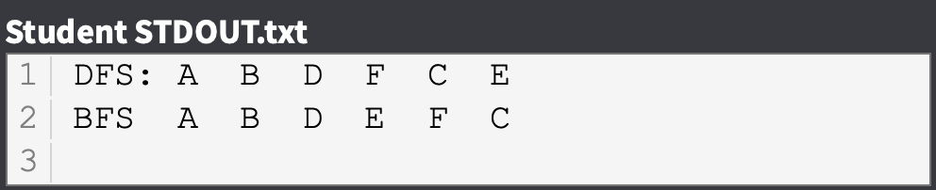

**Task2**

* Graph was implemented using Adjacency Matrix.

